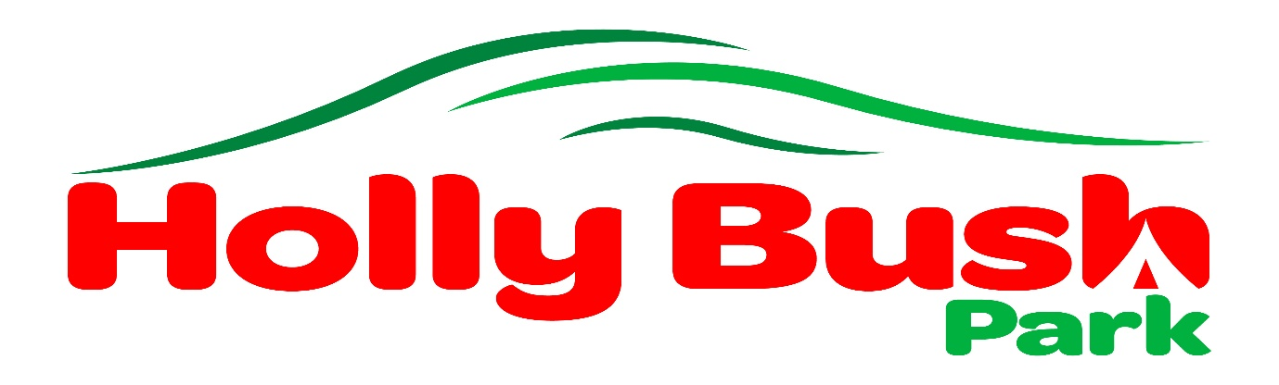

Seasonal Pitch Agreement 2020
(12 month period, maximum of 140 days for 2 named people)

Seasonal Pitch Customer

Name …………………………………….
Address ………………………………….
…………………………………………….
………… Postcode …………………….

Telephone number ……………………………… Mobile …………………………………
Email address ……………………………………..

Description of caravan/motorhome

Make ………………………………………
Model ……………………………………..
Registration no …………………………..
Insurer …………………………………….. Policy no …………………………………………

Hitch lock….. yes/no Wheel lock…..yes/no Alarm…..yes/no
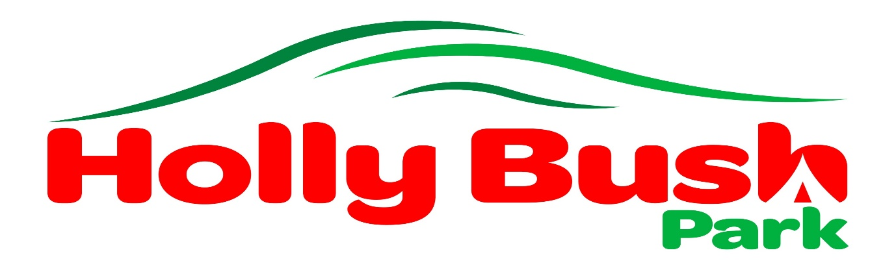
Terms and Conditions for Seasonal Pitches
Awnings
Please ensure that your guy ropes do not encroach on to the grass area outside of your hardstanding.
Only a single awning is permitted on your seasonal pitch (this is considered to be the length of the unit and not more than 5 metres deep).
No equipment is to be stored beneath the unit when it is unoccupied.
Electric Hook-up points
Strictly one hook up per caravan. Please do not leave caravans plugged into the hook up points when they are unoccupied. If an additional hook up is required for any reason please discuss this with us first.
Gas Bottles
Only gas bottles that fit in the gas locker are permitted. No other dangerous or flammable materials may be left on or near your pitch.
Guests
Overnight guests will incur a charge (see current price list). Please advise us of any visitors prior to arrival so that we know who is on site.
Hard standings
We would appreciate it if you will ensure that BBQ’s remain on your own hardstanding and not on the grass areas.
Insurance
All caravans/motorhomes must be covered by adequate insurance at all times and a copy of the insurance must be handed in at Reception to be held on file.
Maintenance of Pitch Area
The “personalisation” of pitches is not permitted, our site is to be used for recreational purposes only and must therefore retain the aspect of all other touring pitches. There can be no boundary fences (windbreaks), planting of flower boxes, bird feeders etc or installation of flooring other than groundsheets.
Pitch holders must undertake to be responsible for the tidy upkeep of the area in the immediate vicinity of their unit and should be prepared to comply with any reasonable request regarding the maintenance of the occupied pitch. Garden furniture, BBQ’s etc must be stored in a suitable garden storage unit.
Pets
We love dogs and they are welcome on site but we respectfully ask that they are kept on a lead whilst on the site. Dog waste should be placed in the general waste bin on site. We are happy to allow a portable dog fence whilst you and your pets are on site.
Unoccupied Units
When leaving your unit unoccupied please let us know and ensure that gas and electric supplies are disconnected. Do not leave perishable food in your unit as this may attract unwanted attention from wildlife.
Use of Units on Site
Units should normally be reversed onto the pitch so that we can gain access in the event of an emergency.
Visits to Site
It is important that we are aware who is on site at all times so we ask seasonal pitch holders to let us know each time they visit either by coming to reception or phoning/texting us prior to arrival. This is a requirement of fire regulations.
Water
Due to high water costs, we do not allow car washing on site. We appreciate that caravans must be cleaned to keep them in good condition and we are happy for you to clean units on site and this will attract a small charge of £5.00.
Wheel Clamps
Where units are fitted with a device, a fully labelled key must be left at Reception in order that your vehicle may be moved in the event of an emergency.

Signed …………………………………… (Owner/Keeper)

Signed …………………………………… (For and on behalf of Holly Bush Park)

Date: ………………………………………

Holly Bush Park
Culmhead
Taunton
Somerset TA3 7EA01823 421515
www.hollybushpark.com
email: info@hollybushpark.com

